Seminar 5

inventory system

The basic Structure for the inventories data that includes the data type for each property of an item.

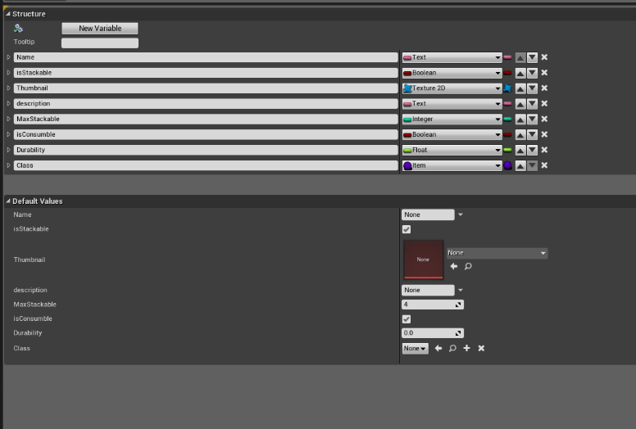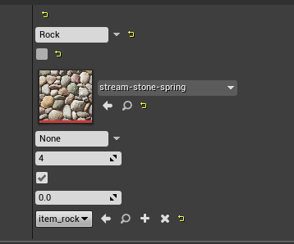

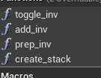

The inventory component contains all of the functions which generate the inventory window as well as the stacking system of each item with these four functions with toggle_inv creating the inventory window itself while the other three prepare the inventory slot data.

With each item I can provide the default values with unique information. For example, the Name and texture that will show up in the inventory screen as well as the max number that can be picked up.

I also included Inheritance for each item which allows me to create different items that all have the same functionality. The base item class calls function from an Inventory component that houses the interactions between the player and items allowing them to pick items up.

The first Function add the item to inventory while also checking if the item is stackable from the item struct, while checking the create Stack function for the is Stackable data on the item structure. The third Function sets up the inventory array to be the correct size.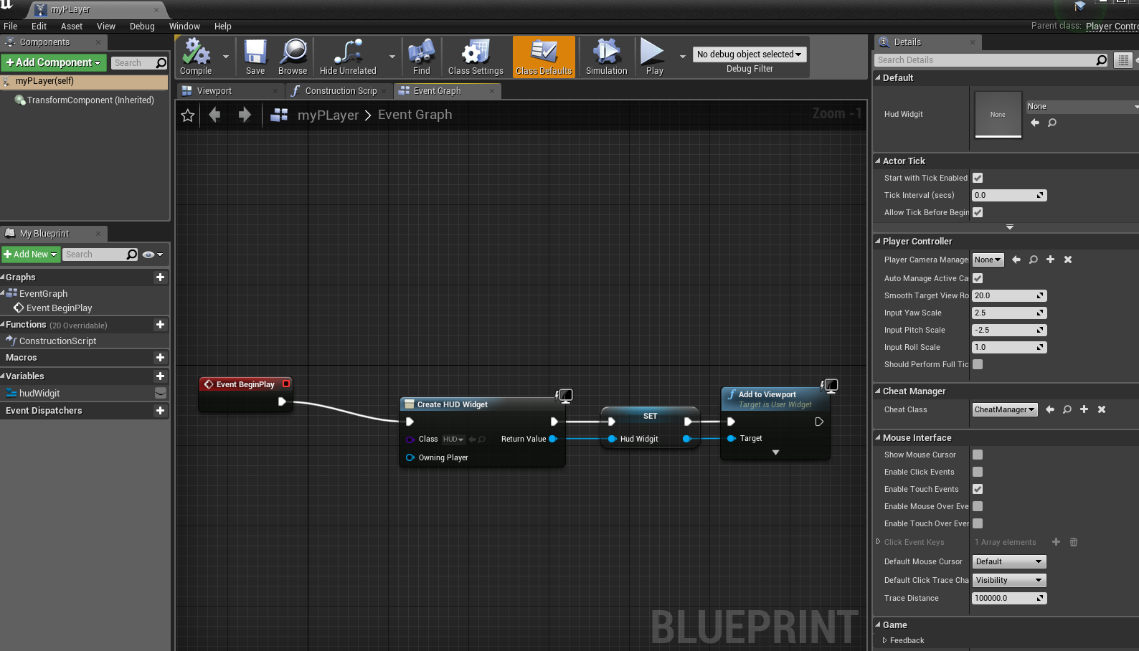 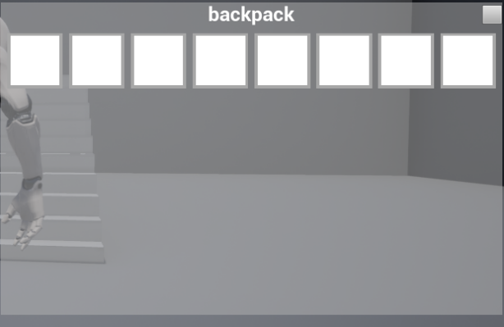

The custom player controller that takes control when the user presses the Interact Key that has been setup in the third person blueprint example which calls the toggle inventory function.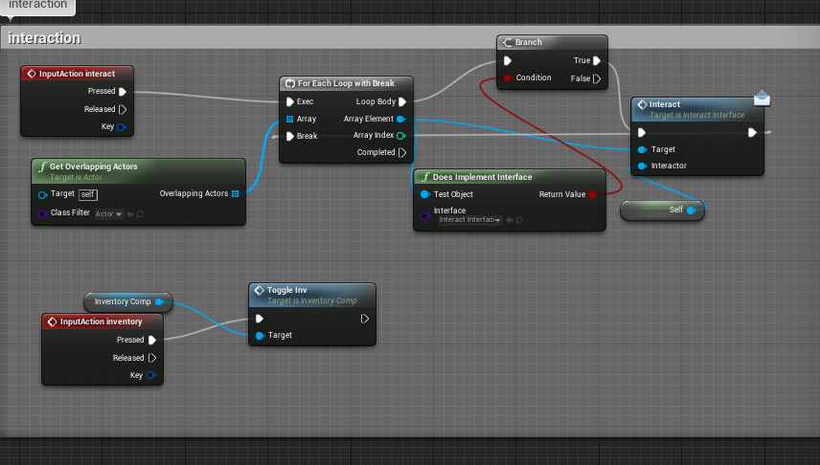

inventory array to the correct amount of slots